**Project registration form**

**Course: Software Engineering KU**   **Field Leader: Prof.Ruvan Abeysekara**

**Student Name: M.F.A.SABITH** **Esoft ID Number: E026503**

**Project Title:** “Leisure Diary” Hassle-free all in one trip organiser.

**Overview**:

AFADAMD (Pvt) Ltd, is a travel agent who assists travelers with their inbound and outbound travel needs, also a trip advisor who works to make sure that travelers are always satisfied. The company's aim is to provide a hassle-free travel experience to all travelers. The company has a huge network of hotels, resorts, other leisure activities, and related services.

Planning a trip could be a complicated task depending on the people or their interests. Planning a trip involves many tasks such as searching and picking a location, arranging transport, finding accommodation, arranging food, and other day-wise activities throughout the trip. People face many resistances when preparing their plans such as being unable to find proper accommodation, having no guidance for the right route plan, no information about the activities around the locations to spend the day, and managing conflicts between the transporter/accommodator which usually happens.

As a solution to the problem the company has come up with an idea to launch the “**Leisure Diary**” mobile application which is an **all-in-one platform** to provide a hassle-free experience in planning and organizing trips. One stop planner application and a social interaction-based application aimed to provide services to both the client and service provider (Hotels, resorts, and other leisure activity providers).

There are many trip planning applications available in the market which fulfil only one task. As an example, Food apps let you only to order food, and transport apps only can be used to book vehicles. But “Leisure Diary” is a **new and unique concept** introduced by the company to assist and break the barriers in planning trips. The application will contain many new features such as **tracking travel, providing suggestions as per travelers’ interest, maintaining the connection between the traveler and the service provider through the application, and much more and to use the application as a social platform where travellers can share their updates, photos and videos of the journey**. Also, to service providers, it helps to reach the customer and expand the business easily under B2B and B2C categories.

**\*Improved list of scope as per supervisor’s feedback.**   
Our unique functionality of the application will be as follows,

* A traveler can log into the application and find and schedule their trip based on their interest (adventurous, site-seeing, historical places, etc...), location or activities (Scuba diving, surfing, camping, etc...).
* Application with social interaction and travel.
* Travelers can plan the trip step by step, for example, you can select your first stop for your accommodation and send them a request, once the accommodator/activity approves the request you will get an alert. Likewise, you can add one or many stops according to your plan. If you’re unable to get the approval you can remove or edit the stop. You can always add or edit your stops with approvals from both ends.
* Travellers will be connected with the transporters, accommodations, and other service providers by a QR code. (E.g., Once the transporter arrived at your pickup location, they will scan your QR code and the trip will commence with the approvals by both parties.) Once the traveler connects through the QR Transporter/accommodator will get full instructions about the stops and other details.
* Travelers can add notes to each stop and service provider.
* Travelers will get time suggestions at each stop based on the average spending of those places.
* Travellers can book Hotels based on prices, food types, and other preferences.
* A traveler without no idea can get suggestions of places and activities just by entering the budget and No. of people.
* Travelers can find ready-made packages automatically by the application of the most visited places.
* Geo-tracking will be available to the traveler and transporter to track their full route map.
* A language translator to be added to the travelers’ advantages.
* You can also add other co-travelers to your trip to track and assign responsibilities to them (When admin allocates a responsibility another co-traveler with getting an alert).
* A group-creating option to add other co-workers and to get votes and comments from them on selected or suggested locations
* Hotels and other leisure places can send alerts to the users regarding the offers and promote their ads through the application.
* An accounting platform to allocate, track, and report their spending on the trip. All the co-travelers can access the report.
* To provide a current update about the location.

**Aims and Objectives**:

**Aim**

Our aim is to Identify the problems and provide an All-in-One hassle-free trip Planning and organizing platform with more new features as a solution to all the travellers, to make the travelling more convenient. One clicks platforms.

**Objectives**

* To provide a one stop platform to find information, suggestions and recommendations to prepare the plan and organize the entire process of travelling.
* To provide a platform (like a social media) which travelers can share their updates and help each other’s get an idea.
* To overcome the barriers in traveling for inbound and outbound travelers. (Language barriers and hassle in finding information if you’re not familiar with the location).
* To maintain a smooth connection and track of record between the travellers and other service providers.
* To provide an accurate information and a summary of the spendings to share with the co-travelers.
* To help the businesses to expand and reach their business to customers and provide them with information about quality services available.

**Supervisor’s Name: Prof. Ruvan Abeysekara**

**(Continues overleaf)**

Member of staff only

**The above project topic is approved and I agree to supervise this project.**

***……………………………….. …………………………..***

*Supervisor’s Signature**Date*

**Remarks :**

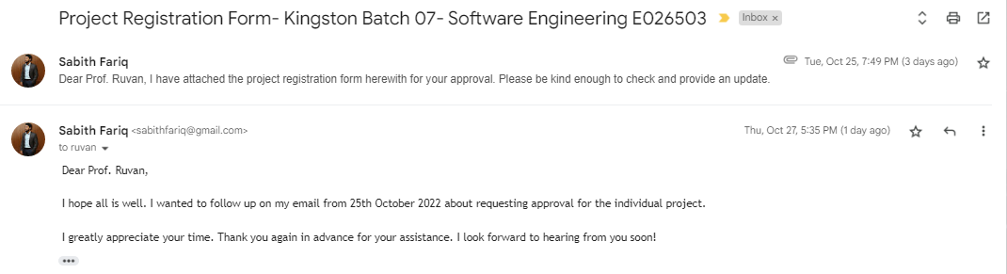Email feedbacks and reminders.

0

Amended scope

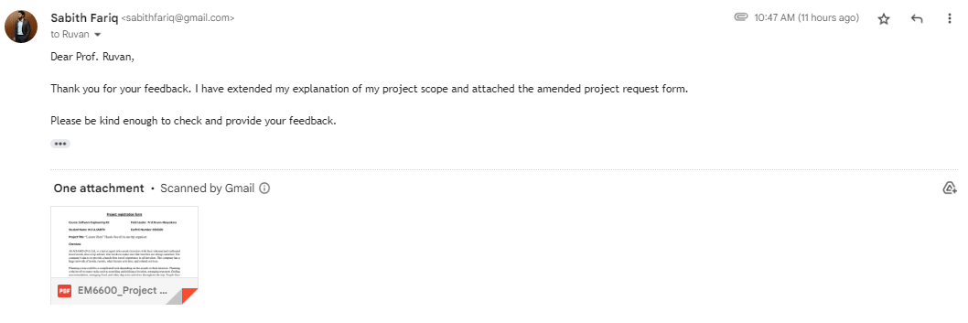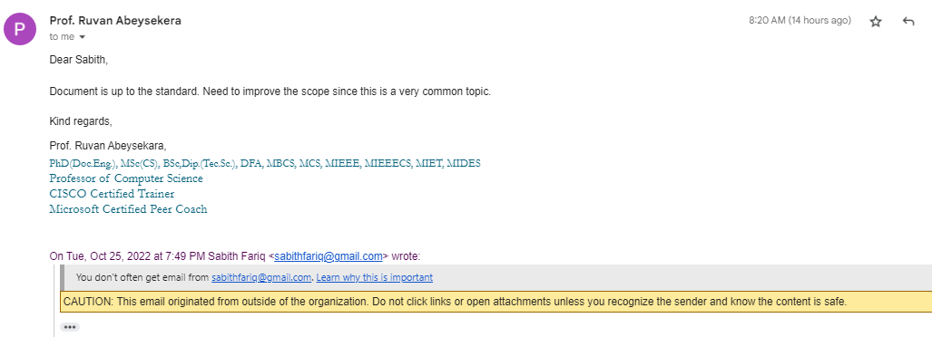

Fri Oct 28, 2022, 8:20 AM

